sara alawieh
201601126 | SMA107@MAIL.AUB.EDU | SECTION 3
CIRCUITS AND ELECTRONICS LAB - ECE 312L
MY DAQ ASSIGNMENT 2

Table of Contents
I. DISCRIPTION OF THE HARDWARE SETUP 3
1. For the first circuit: 3
a. Circuit connections: 3
b. Connections between MyDAQ acquisition board and the circuit. 4
c. Input and Output lines 5
d. Photo depicting hardware setup and connections: 5
2. For the second circuit 6
a. Circuit Connections: 6
b. Connections between MyDAQ acquisition board and the circuit. 7
c. Input and Output lines: 7
d. Photo depicting hardware and connections: 7
3. For the third circuit: 8
a. Circuit connections: 8
b. Connections between MyDAQ acquisition board and the circuit. 9
c. Input and Output lines: 10
d. Photo depicting hardware setup and connections: 10
4. For the fourth circuit: 11
a. Circuit connections: 11
b. Connections between MyDAQ acquisition board and the circuit. 12
c. Input and Output lines 13
d. Photo depicting hardware setup and connections: 13
II. Description of the software setup 14
1. Modules used and configurations: 14
a. Function generator FGEN: 14
b. Digital multimeter DMM 15
c. Oscilloscope: 17
III. Testing 18
1. Measure the 1K ohm resistor. 18
2. Measure the 5.6K ohm resistor: 18
3. For the first circuit: 19
4. For the second circuit 21
5. For the third circuit: 23
6. For the Fourth circuit: 24
IV. References 25

DISCRIPTION OF THE HARDWARE SETUP

For the first circuit:

Circuit connections:
The purpose was to implement and test the characteristics of the one diode clipping circuit shown in the figure below. The diode is connected in series with the 5.6K Ohm resistor.
Figure 1 One Diode clipping circuit
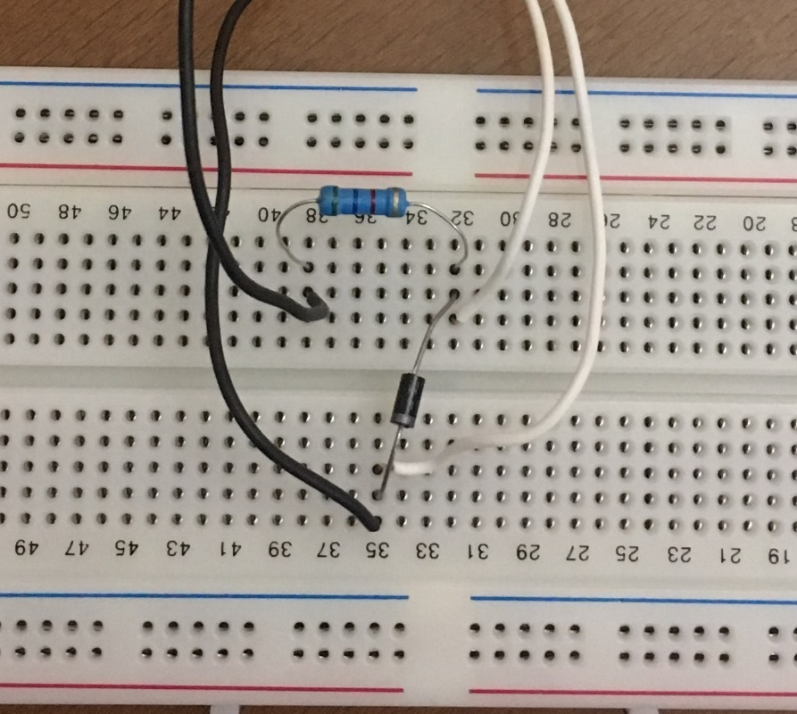
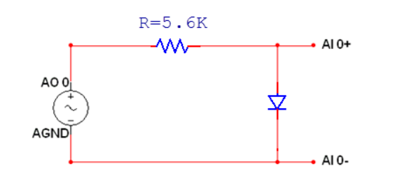
.
Figure 2 circuit connections

Connections between MyDAQ acquisition board and the circuit.

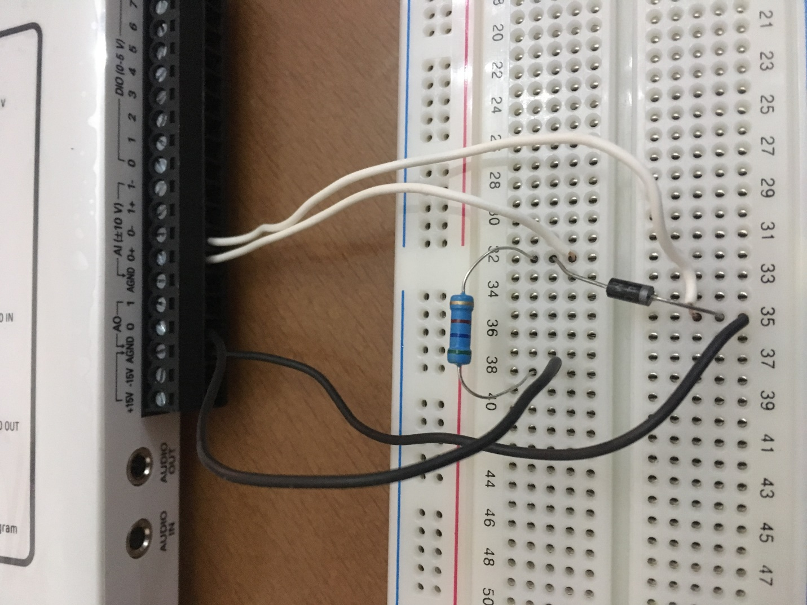
Figure 3 Connections between MyDAQ acquisition board and the circuit.

Input and Output lines

- Analog output AO 0 is used to input a signal to the circuit design built. Connect this line of the MyDAQ to the resistor.
- The ground of the circuit is the AGND line of the MyDAQ connected to the diode.
- Analog input lines AI 0 and AI 1of the MyDAQ are used to display the output signal of the circuit. AI 0 is used here to display the appropriate measurements with the oscilloscope of the rectified signal. Connect AI 0⁺ and AI 0⁻ across the diode.

Photo depicting hardware setup and connections:

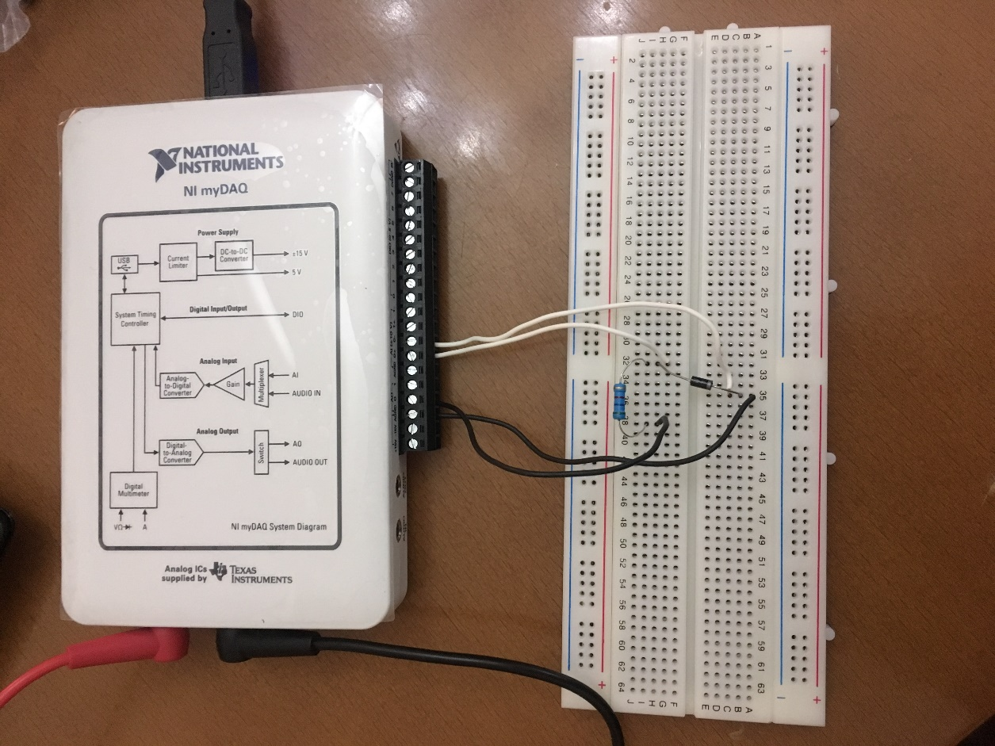
Figure 4 Hardware setup and connections

For the second circuit

Circuit Connections:
The purpose was to implement and test the characteristics of the one Zener clipping circuit shown in the figure below. The Zener is connected in series with the 1K Ohm resistor.

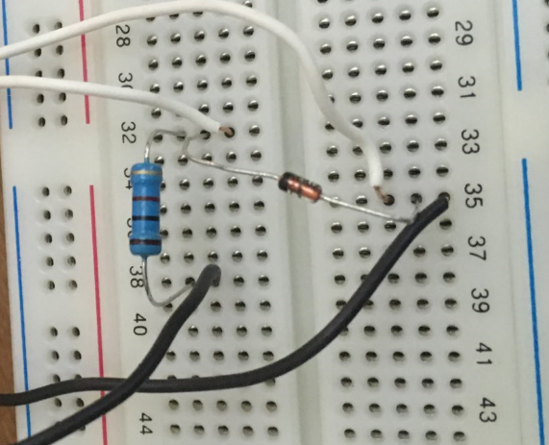
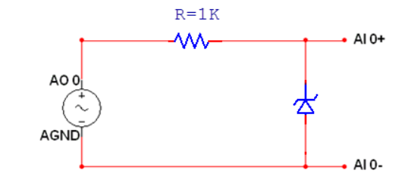
Figure 5 One Zener clipping circuit
Figure 6 Circuit Connections

Connections between MyDAQ acquisition board and the circuit.

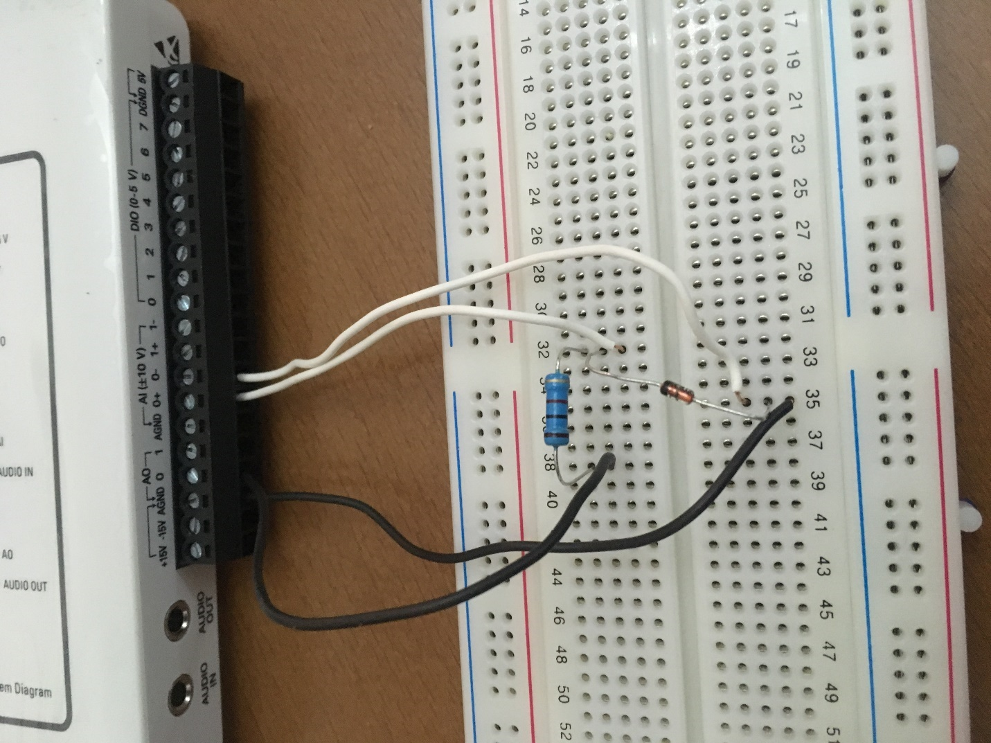
Figure 7 Connections between MyDAQ acquisition board and the circuit

Input and Output lines:

- Analog output AO 0 is used to input a signal to the circuit design built. Connect this line of the MyDAQ to the resistor.
- The ground of the circuit is the AGND line of the MyDAQ connected to the Zener.
- Analog input lines AI 0 and AI 1of the MyDAQ are used to display the output signal of the circuit. AI 0 is used here to display the appropriate measurements with the oscilloscope of the rectified signal. Connect AI 0⁺ and AI 0⁻ across the Zener.

Photo depicting hardware and connections:
Figure 8 photo depicting hardware and connections

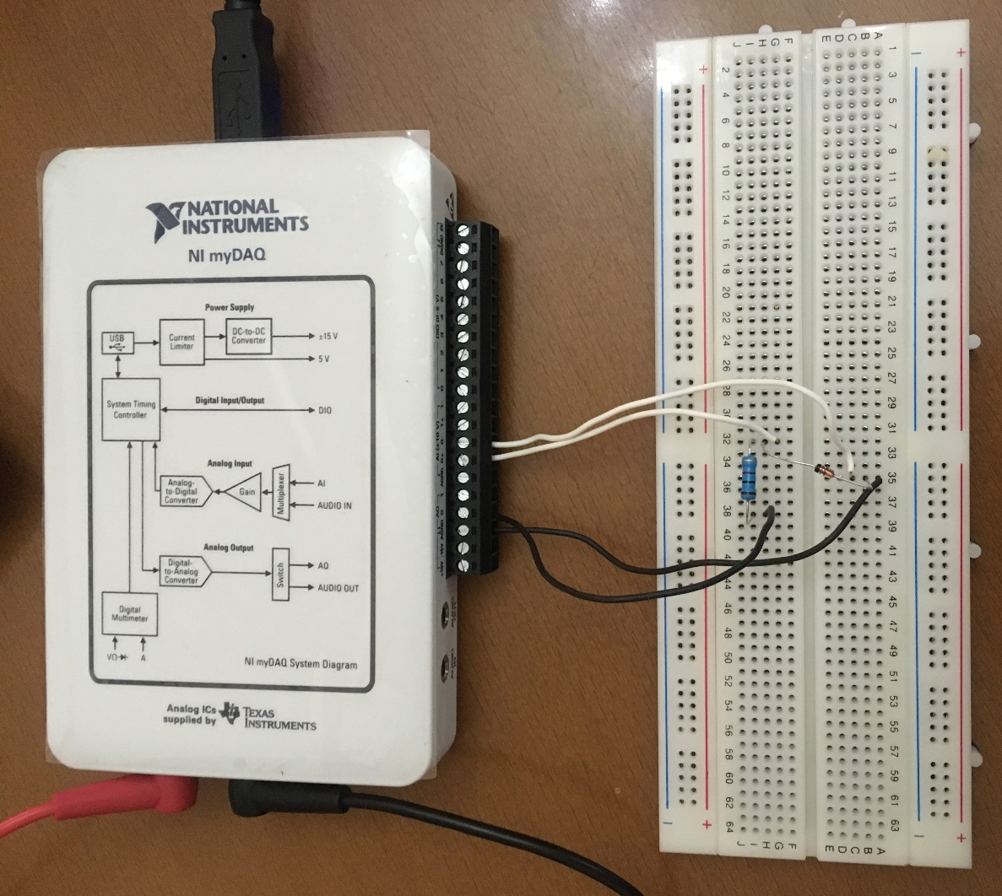

3. For the third circuit:

a. Circuit connections:
The purpose was to implement and test the characteristics of the two diode clipping circuit shown in the figure below. The diodes are connected in parallel. Their parallel combination is connected in series with the 5.6K Ohm resistor.
.
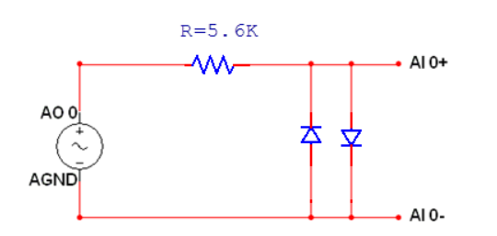
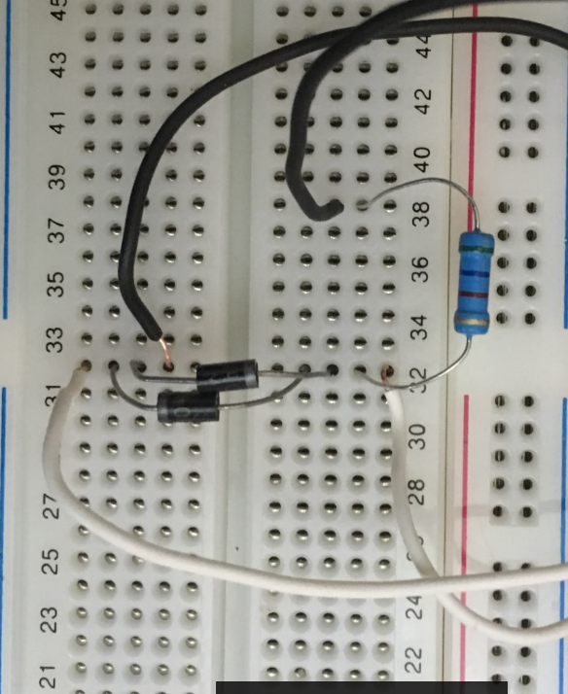
Figure 11 circuit connections
Figure 10 two Diode clipping circuit

b. Connections between MyDAQ acquisition board and the circuit.

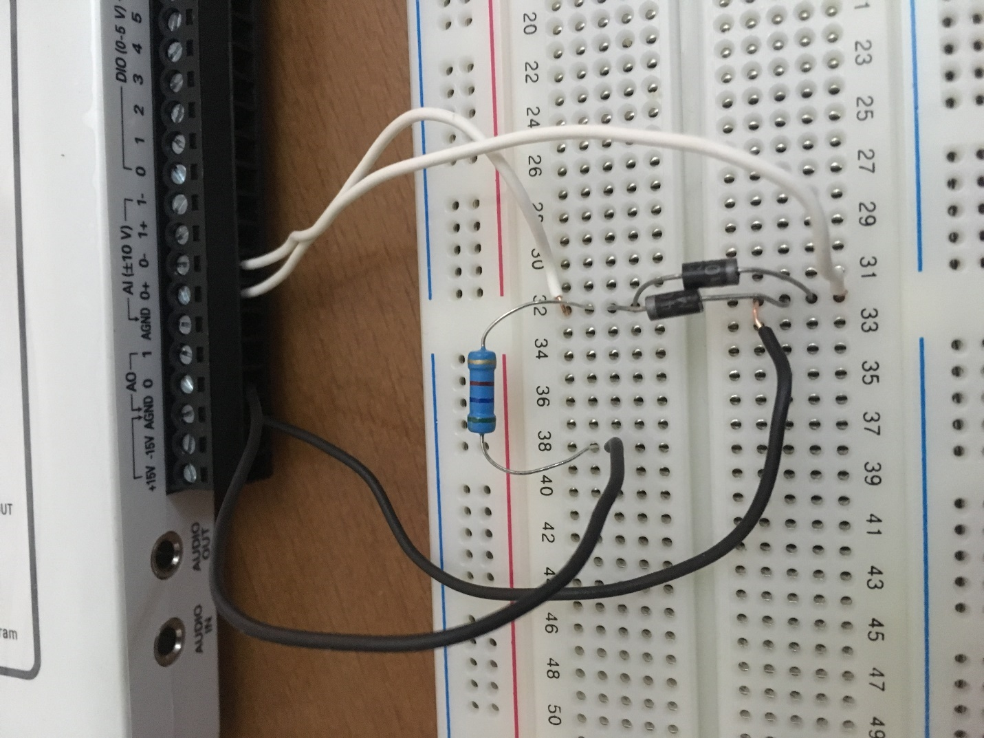
Figure 12 Connections between MyDAQ acquisition board and the circuit.

c. Input and Output lines:

- Analog output AO 0 is used to input a signal to the circuit design built. Connect this line of the MyDAQ to the resistor.
- The ground of the circuit is the AGND line of the MyDAQ connected to the diodes.
- Analog input lines AI 0 and AI 1of the MyDAQ are used to display the output signal of the circuit. AI 0 is used here to display the appropriate measurements with the oscilloscope of the rectified signal. Connect AI 0⁺ and AI 0⁻ across the diodes.

Photo depicting hardware setup and connections:
Figure 13 Hardware setup and connections

For the fourth circuit:

Circuit connections:

The purpose was to implement and test the characteristics of a diode clipping circuit with a 3V DC source as shown in the figure below. The diode is connected in series with the 5.6K Ohm resistor. To get 3V DC from the 5V DC source, a voltage regulator circuit is used. (figure 15) The regulator circuit consisting of 1K resistor connected in series with the 3V Zener diode uses the 5V DC source of MY-DAQ board. The output of this circuit will be the DC source to be used in series with the diode in the clipper circuit.
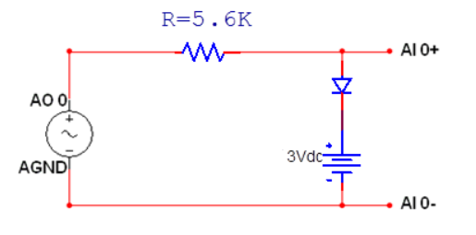
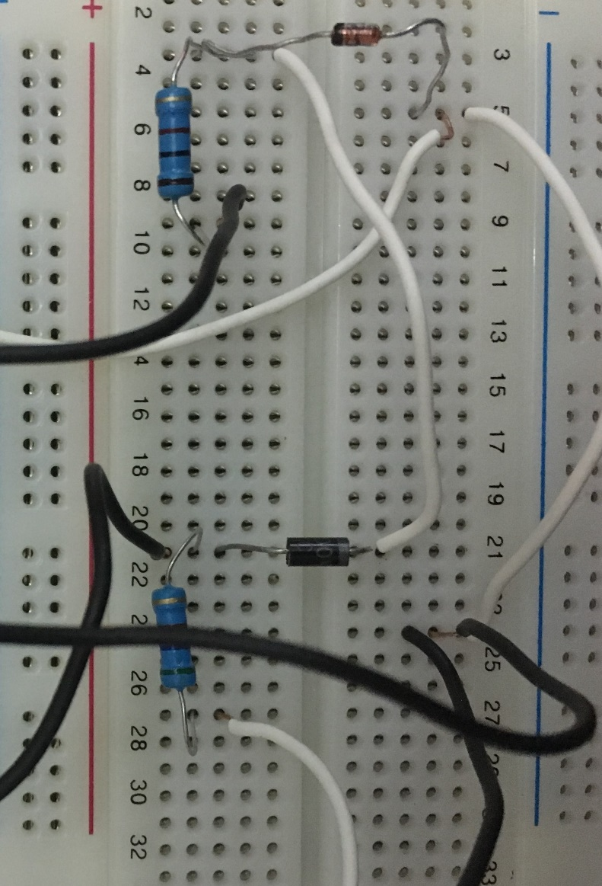
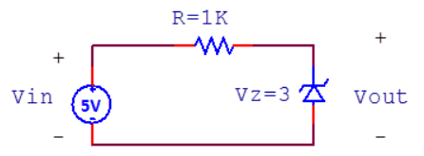
Figure 16 Diode clipping circuit with a DC voltage source
Figure 14 Diode clipping circuit with DC source
Figure 15 Voltage regulator Circuit

Connections between MyDAQ acquisition board and the circuit.
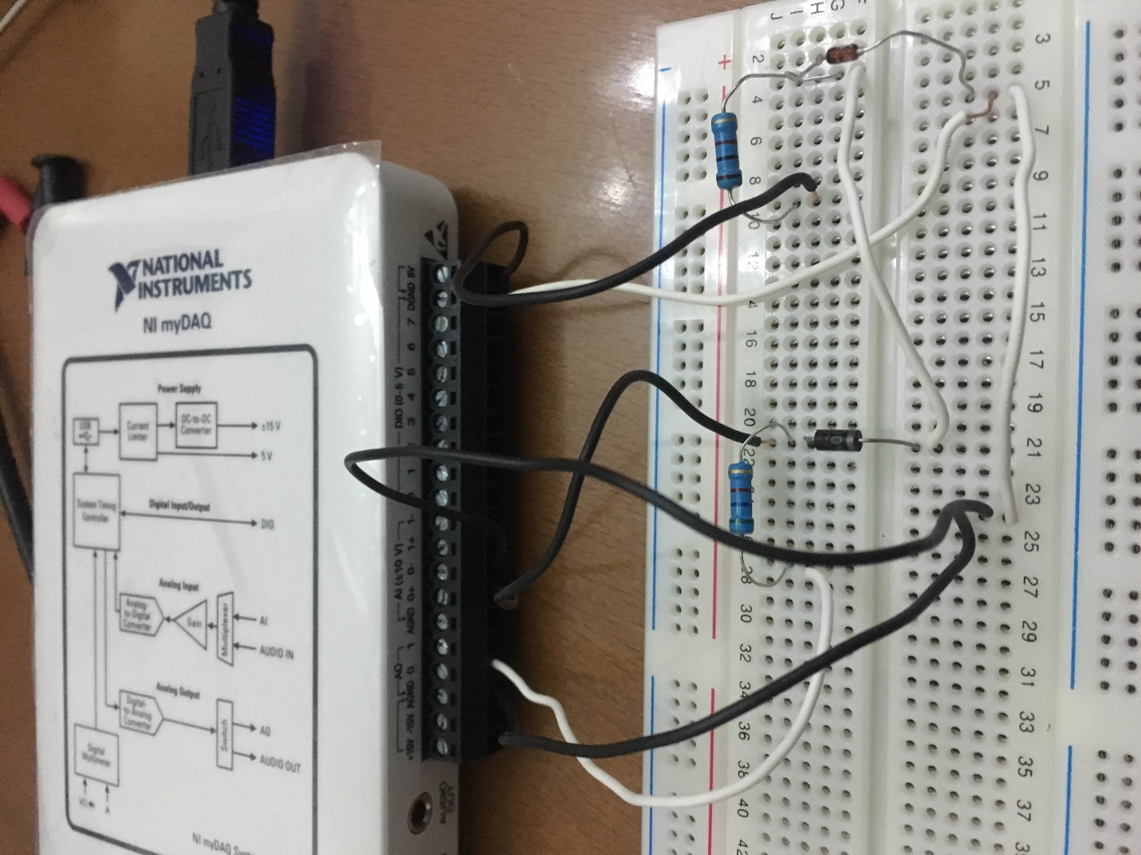
Figure 17 Connections between MyDAQ acquisition board and the circuit.

Input and Output lines

- Analog output AO 0 is used to input a signal to the circuit design built. Connect this line of the MyDAQ to the resistor.
- The ground of the circuit is the AGND line of the MyDAQ connected to the diodes.
- Analog input lines AI 0 and AI 1of the MyDAQ are used to display the output signal of the circuit. AI 0 is used here to display the appropriate measurements with the oscilloscope of the rectified signal. Connect AI 0⁺ and AI 0⁻ across the diodes.

Photo depicting hardware setup and connections:

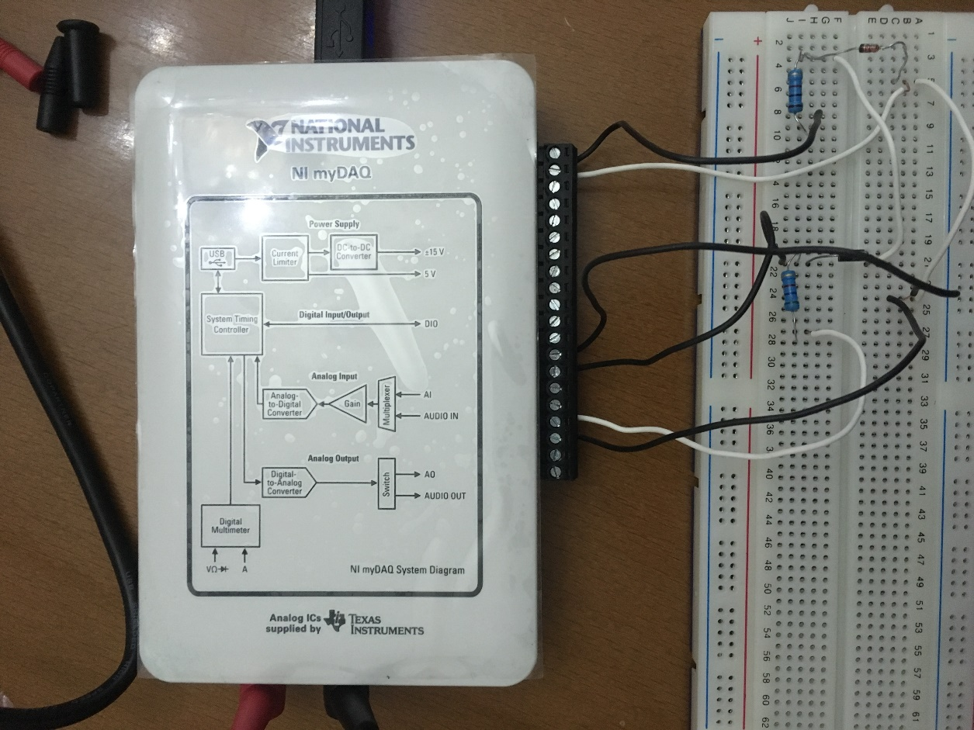
Figure 18 Hardware setup and connections

Description of the software setup

Modules used and configurations:
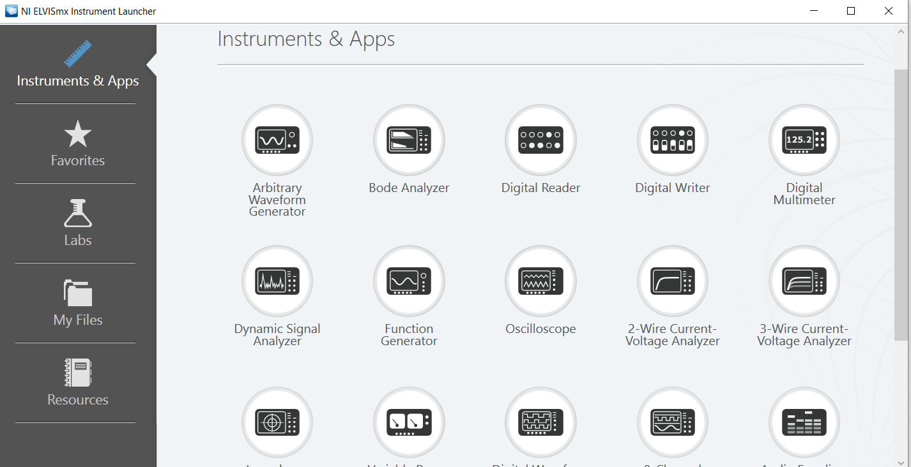
Connect the MyDAQ to the PC, NI ELVISmx Instrument Launcher will start automatically.

Figure 19 NI ELVISmx Instrument Launcher

Function generator FGEN:

Choose the function generator for the launcher.
The NI ELVISmx Function Generator (FGEN) generates standard waveforms with options for the type of output waveform (sine, square, or triangle), amplitude selection, and frequency settings. The FGEN uses AO 0 on the screw terminal connector. Hence, analog output AO 0 will be used to input a signal to the circuit design built on the breadboard.
In all the circuits, a sinusoidal wave of 1k HZ frequency and different peak to peak voltage is used. The function generator is adjusted through its menu to match the requirements and the button “run” delivers the input to the circuit.

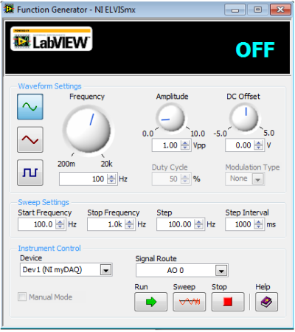

Figure 20 Function Generator

Digital multimeter DMM

NI ELVISmx Digital Multimeter (DMM) is a stand-alone instrument that controls the basic DMM capabilities of NI myDAQ. This commonly used instrument can perform the following types of measurements:
• Voltage (DC and AC)
• Current (DC and AC)
• Resistance
• Diode test.
- Audible continuity
To use the DMM for measurements, make connections to the DMM banana jacks on the device. This instrument has the following measurement parameters:
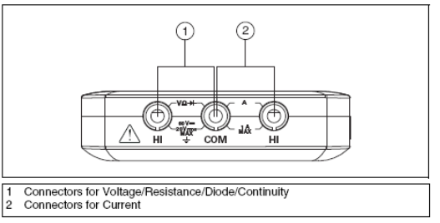

• DC voltage: 60 V, 20 V, 2 V, and 200 mV ranges
• AC voltage: 20 V, 2 V, and 200 mV ranges
• DC current: 1 A, 200 mA, and 20 mA ranges
• AC current: 1 A, 200 mA, and 20 mA ranges
• Resistance: 20 MΩ, 2 MΩ, 200 kΩ, 20 kΩ, 2 kΩ, and 200 Ω ranges
• Diode: 2 V range

Make the connections to the DMM banana jacks on the device, and choose DMM from the launcher. Choose the ohm button to measure the resistance and click “run”.
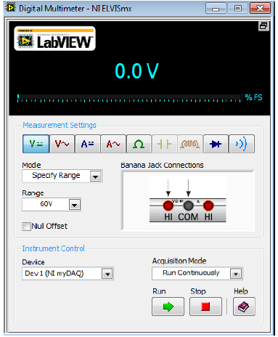

Figure 21 Digital Multimeter

Oscilloscope:
The NI ELVISmx Oscilloscope (Scope) displays voltage data for analysis. This instrument provides the functionality of the standard desktop oscilloscope found in typical undergraduate laboratories.
The NI ELVISmx Oscilloscope SFP has two channels and provides scaling and position adjustment knobs along with a modifiable time-base. The auto-scale feature allows you to adjust the voltage display scale based on the peak-to-peak voltage of the AC signal for the best display of the signal. The computer-based scope display has the ability to use cursors for accurate screen measurements. Channel Source: Channels AI 0 and AI 1. Hence, analog input lines (AI 0 or AI1) of myDAQ will be used to display the output signal from the circuit design built on the breadboard. This means that you will use one analog input line in order to read the output waveform (rectified signal) generated from the built circuit.
Note that AI Channels support DC Coupling only.

Choose the oscilloscope from the launcher. In this experiment, only one analog input line AI 0 is used with terminal AI 0⁺ and AI 0⁻, so Channel 0 is enabled.
Adjust the scale and vertical position according to each circuit and use the cursors to determine Vmin and Vmax. To start viewing the wave forms, click “run”.

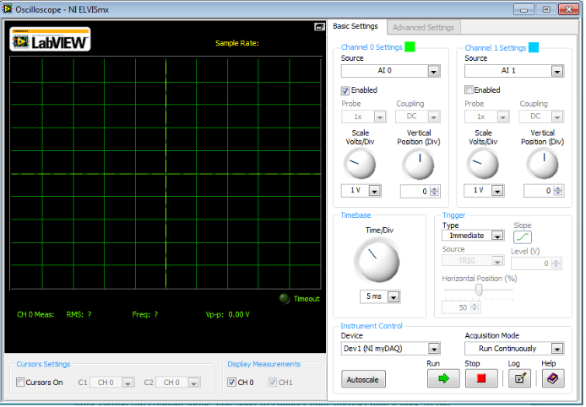
Figure 22 oscilloscope

Testing

Measure the 1K ohm resistor.
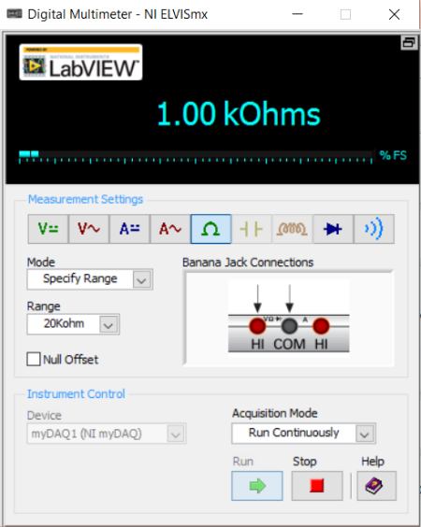

Figure 23 Digital Multimeter

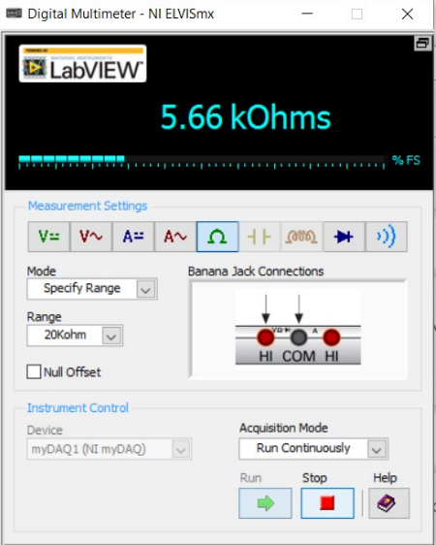
Measure the 5.6K ohm resistor:
Figure 24 Digital Multimeter

For the first circuit:
 | V_{min} | V_{max} | V_{peak}
2V peak to peak | -1V | 487.09 mV | 1.490 V
3V peak to peak | -1.5V | 514.51 mV | 2.018 V
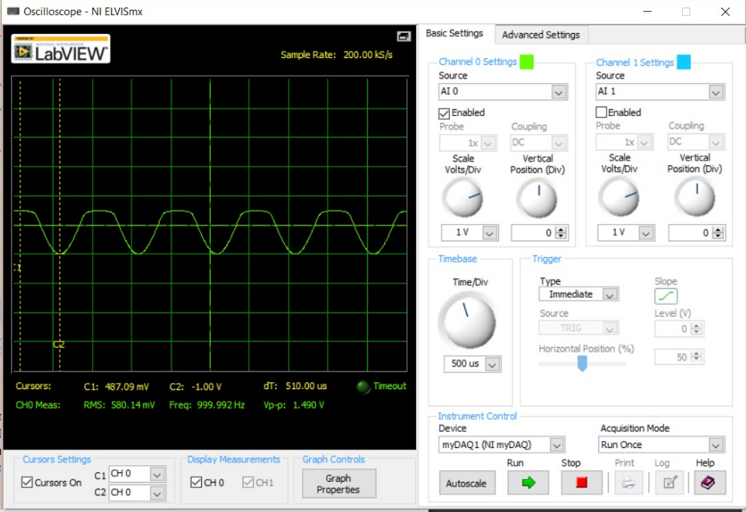
Figure 25 waveforms for the 2V peak to peak

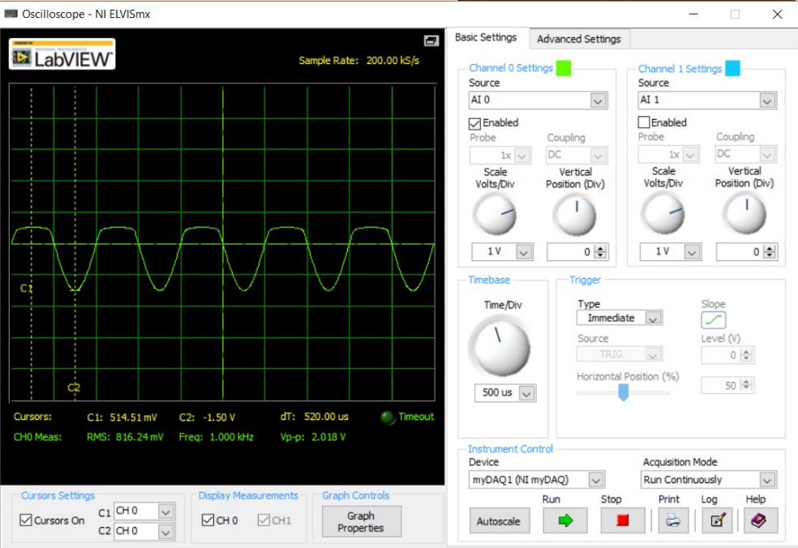
Figure 26 waveforms for the 3V peak to peak

For the second circuit

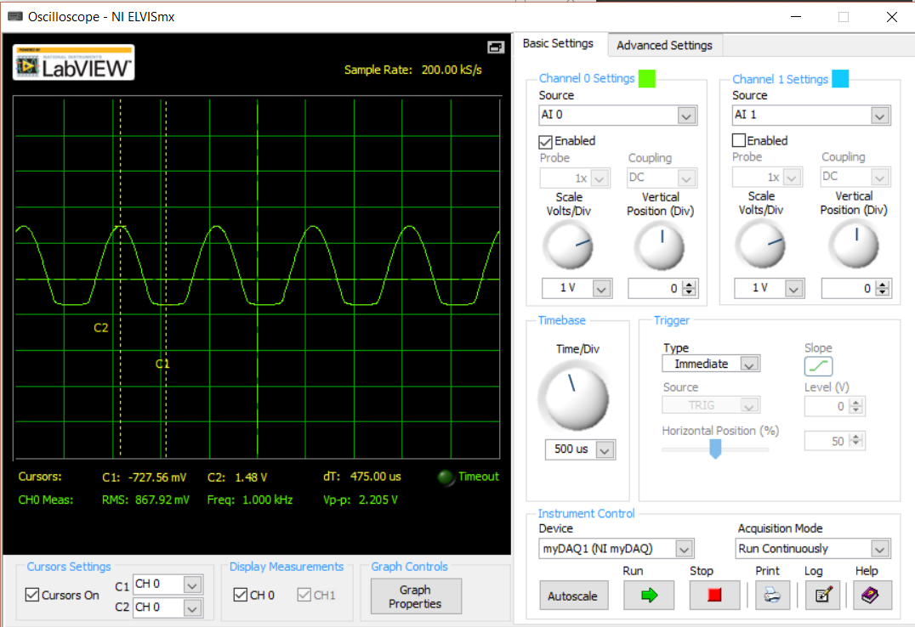
Figure 26 waveforms for the 3V peak to peak
 | V_{min} | V_{max} | V_{peak}
3V peak to peak | -727.56 mV | 1.48 V | 2.205 V
10V peak to peak | -756.51 mV | 2.74 V | 3.5 V
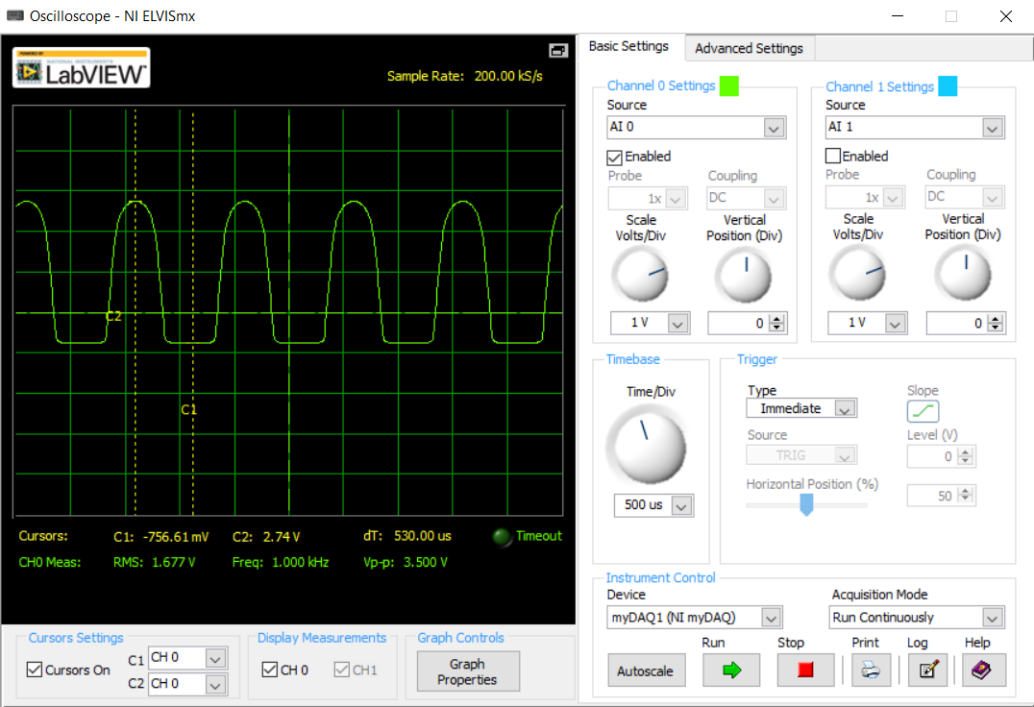
Figure 27 Waveforms for the 10V peak to peak

For the third circuit:
 | V_{min} | V_{max} | V_{peak}
10V peak to peak | -484.04 mV | 481.22 mV | 966.57 mV

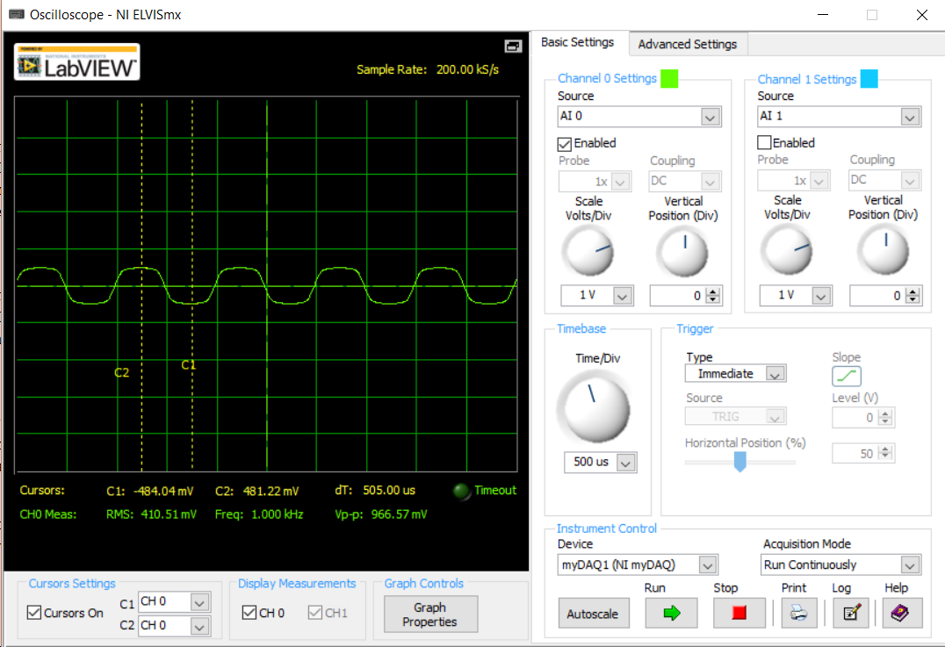
Figure 28 waveforms for the 10V peak to peak

For the Fourth circuit:

 | V_{min} | V_{max} | V_{peak}
10V peak to peak | -5.00 V | 3.30 V | 8.302 V

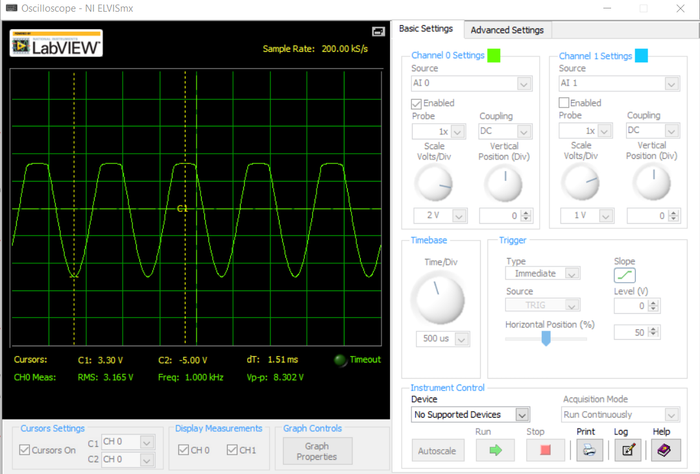
Figure 29 waveforms for 10V peak to peak

References
MyDAQ assignment 2 manual:
http://moodle.aub.edu.lb/pluginfile.php/228351/mod_resource/content/3/EECE312L_Assignment2_MYDAQ.pdf

